Faculties’ Perception Study

# **Teaching and learning**

Mostly teachers are satisfied with the teaching learning process in the college and rank either 4 or 5 across departments.

## Overall environment for teaching

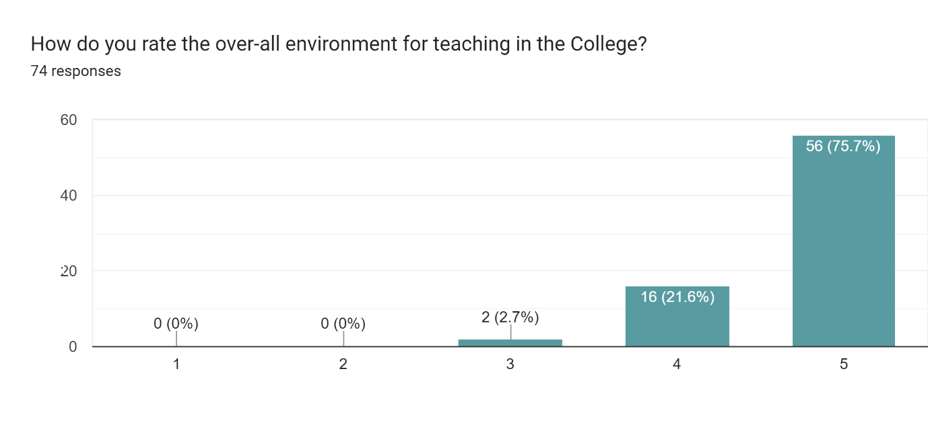

## Overall environment for learning

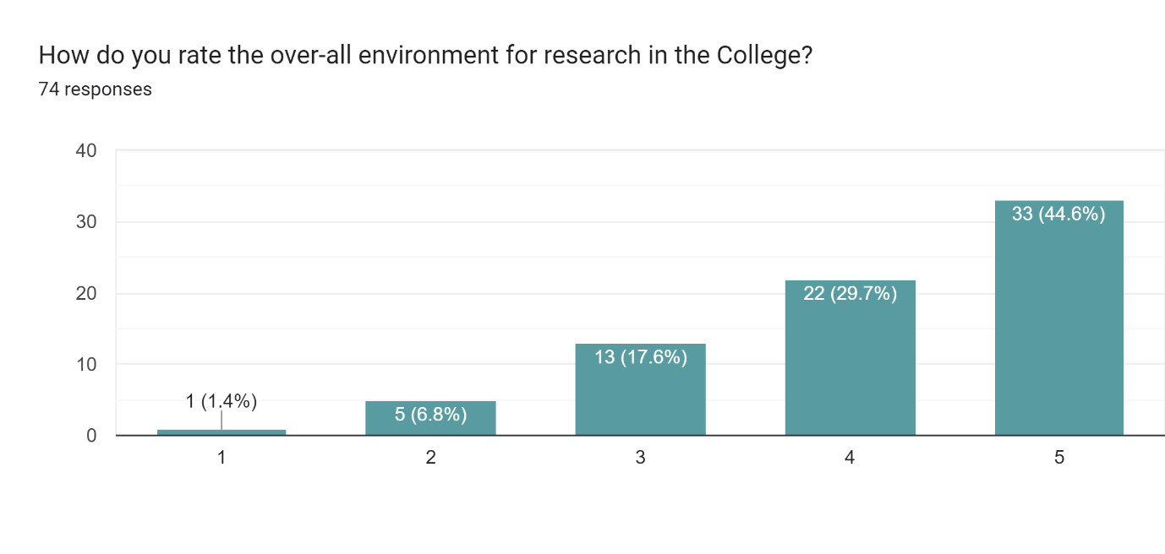

## Inclusiveness in decision making

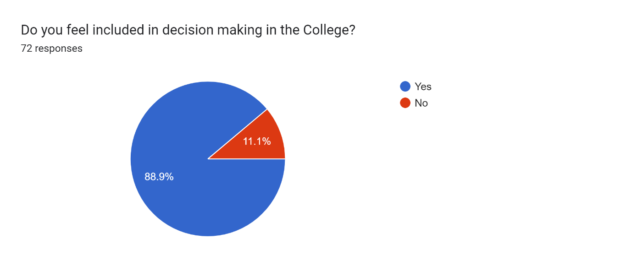

# **Infrastructure**

Mostly teachers are satisfied with the infrastructure facility in the college and rank either 4 or 5 across departments.

## ICT facility

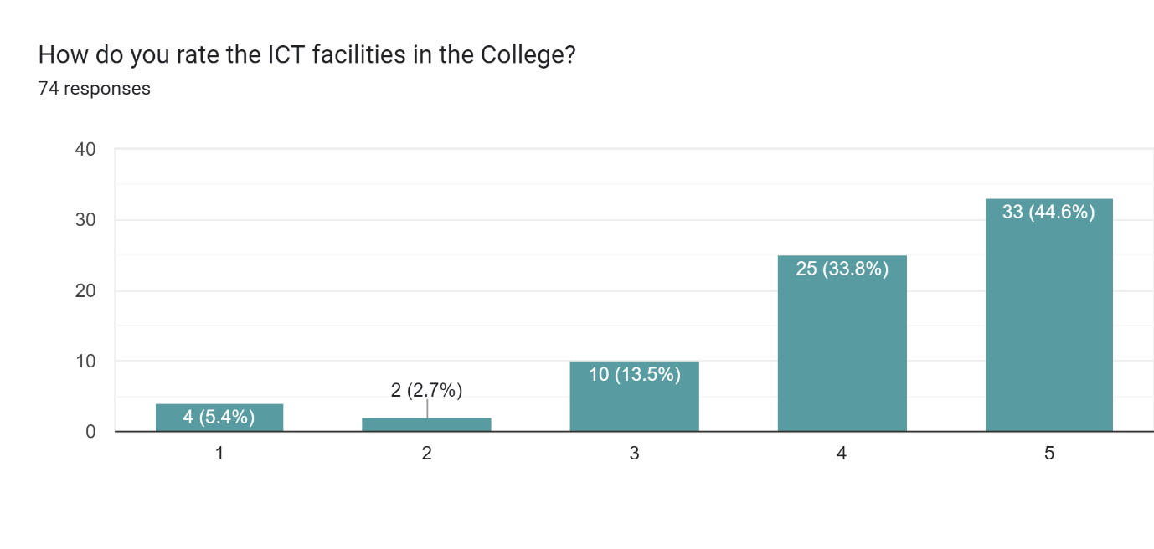

## Library facilities

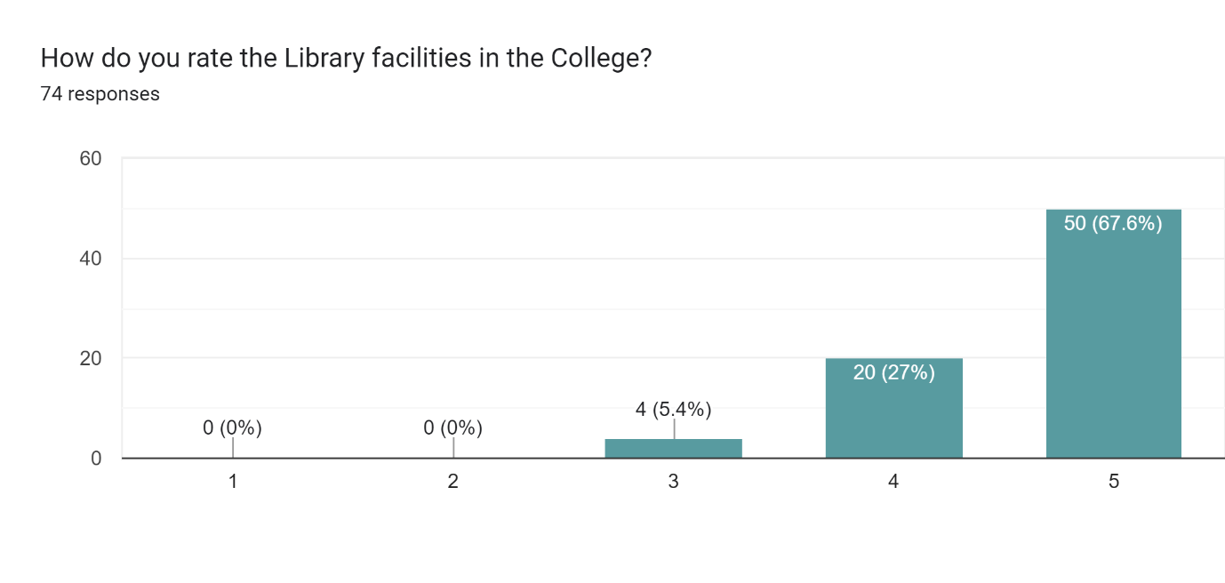

## Infrastructure rating

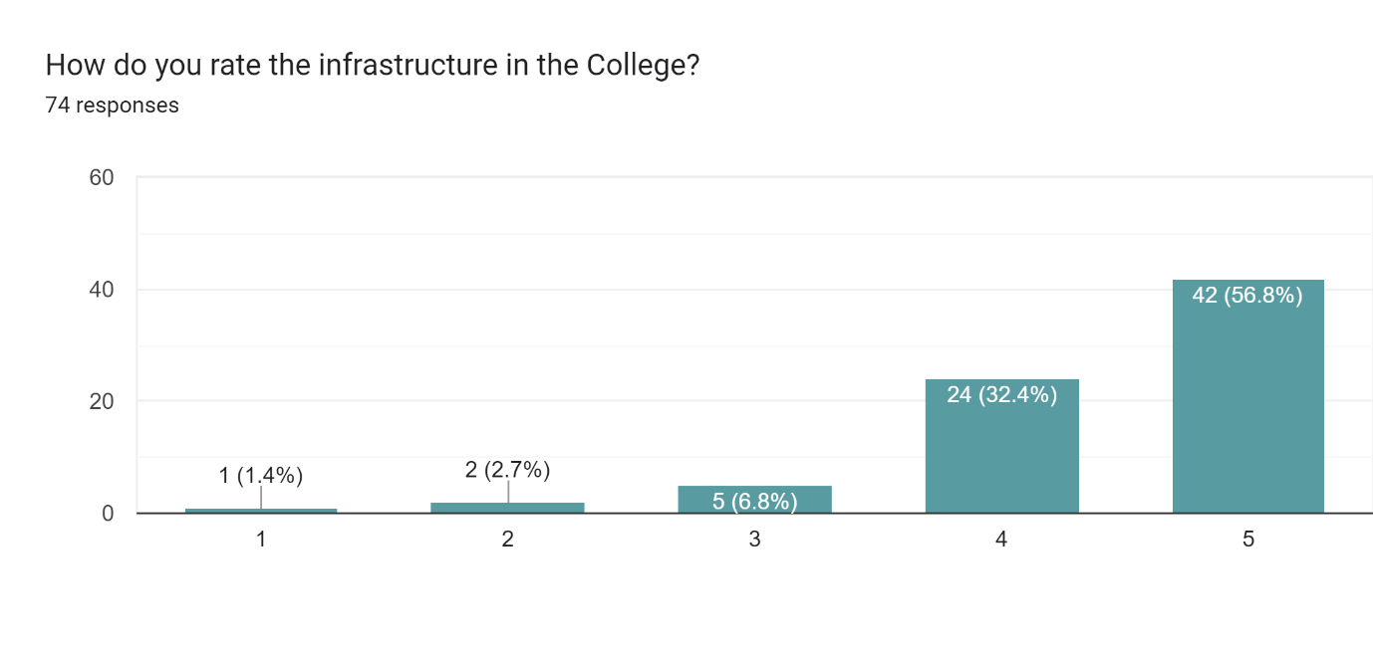

## Maintenance and cleanliness of teaching space

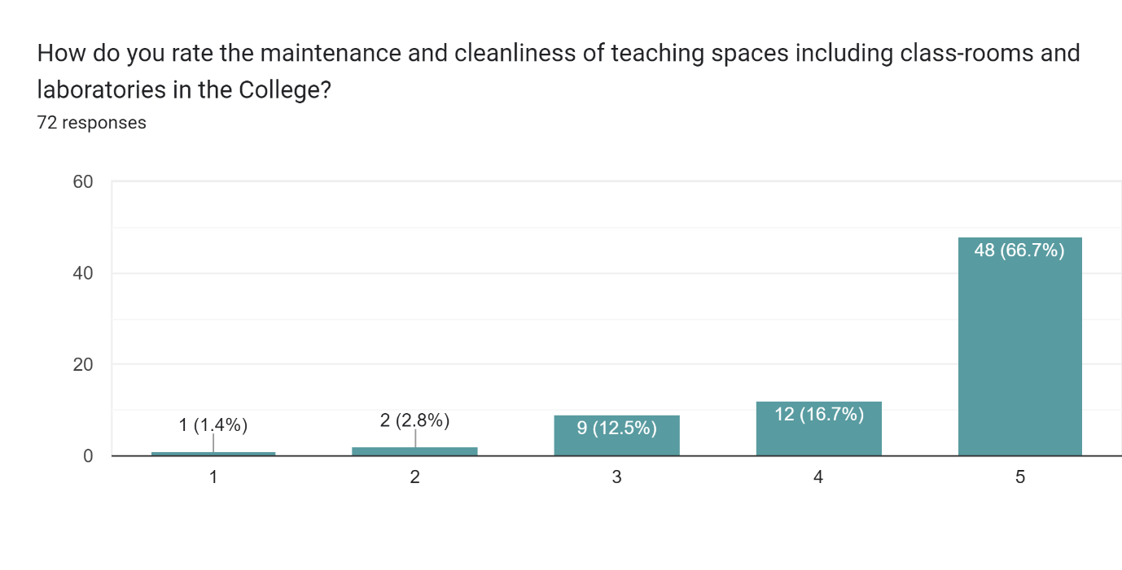

## Maintenance and cleanliness of common area

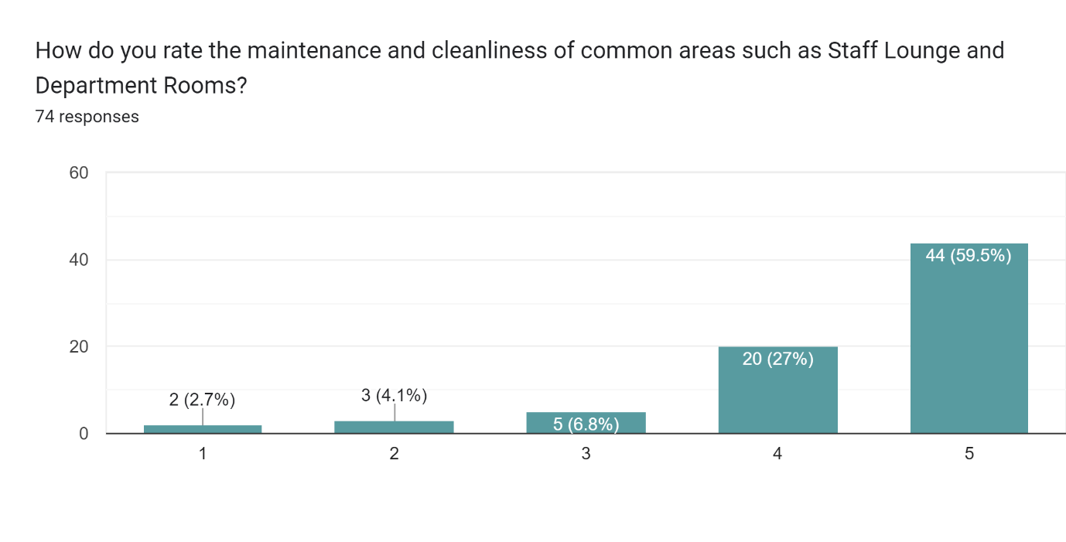

## Canteen facilities

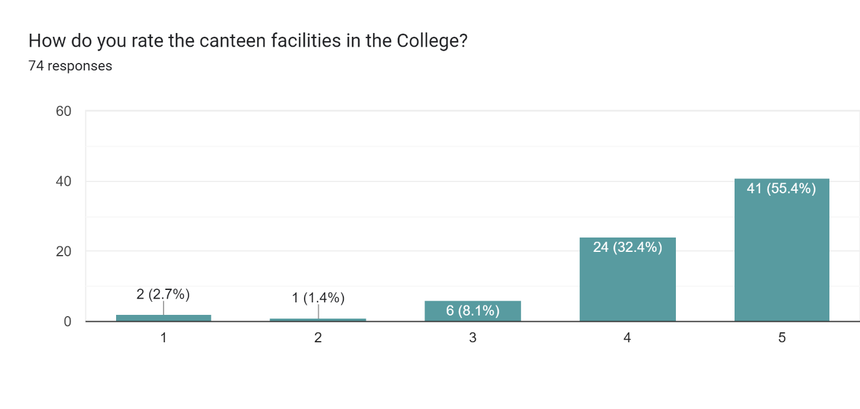

## Primary medical facilities

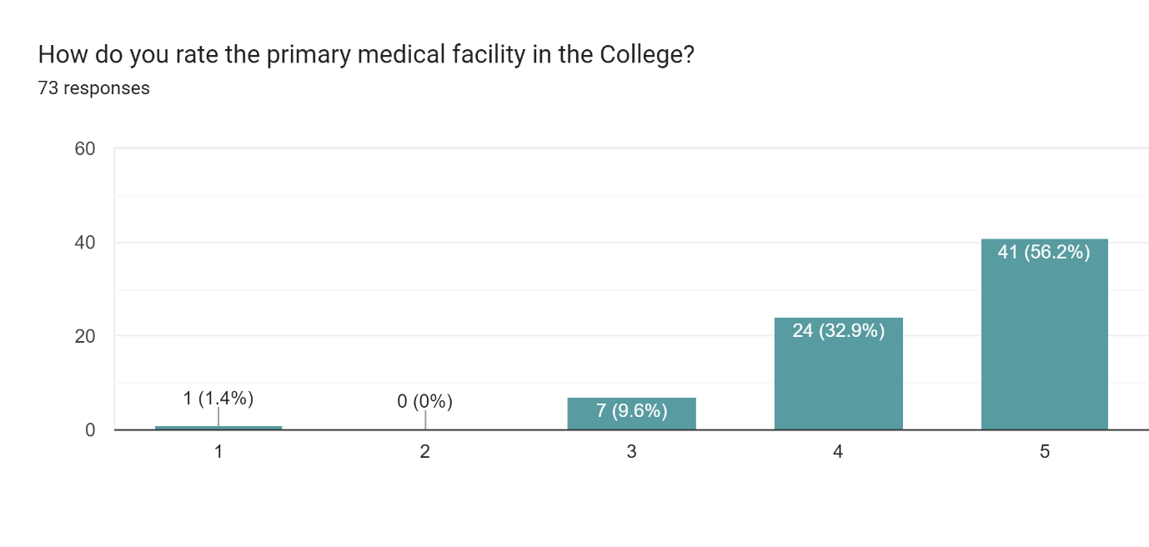

## Banking facility

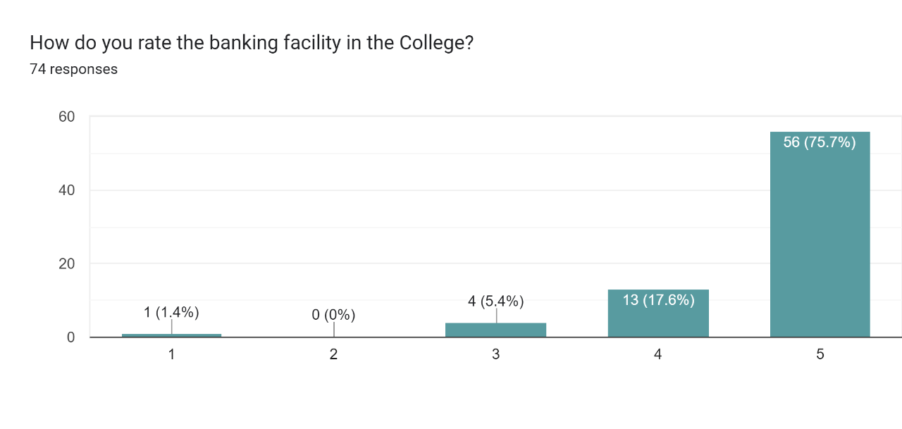

# **Human Resource Management**

Mostly teachers are satisfied with the ongoing human resource management in the college and rank either 4 or 5 across departments.

## Accessibility and support of the administrative staff

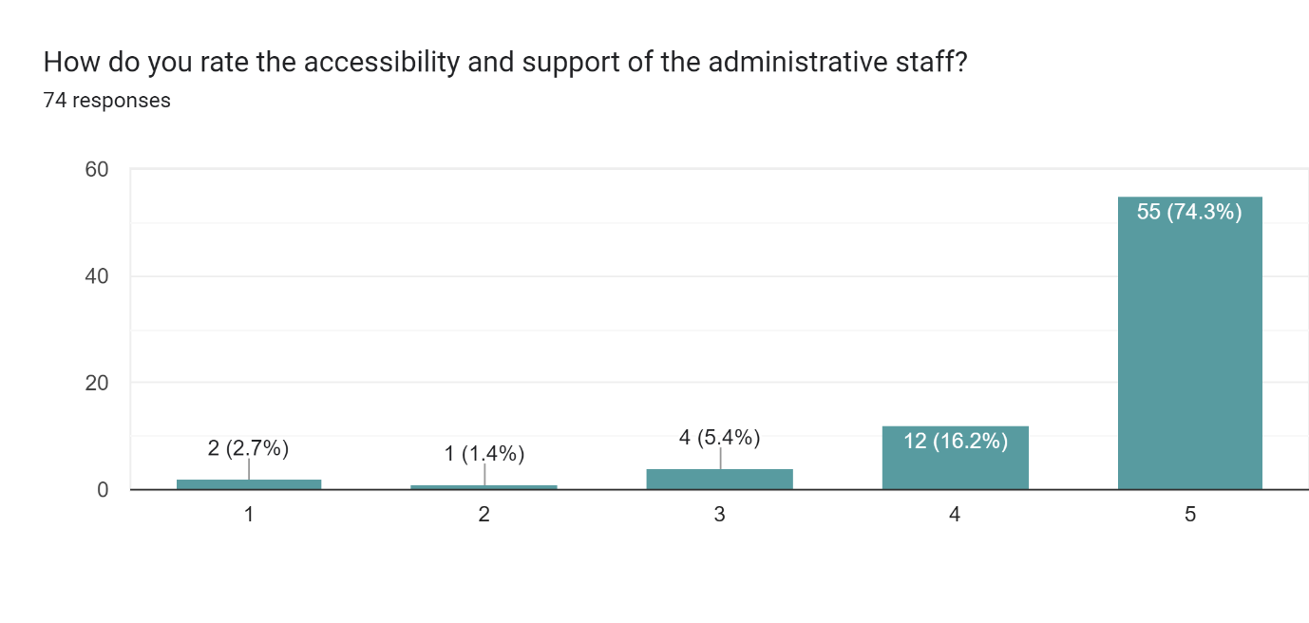

## On-time disbursal of salary

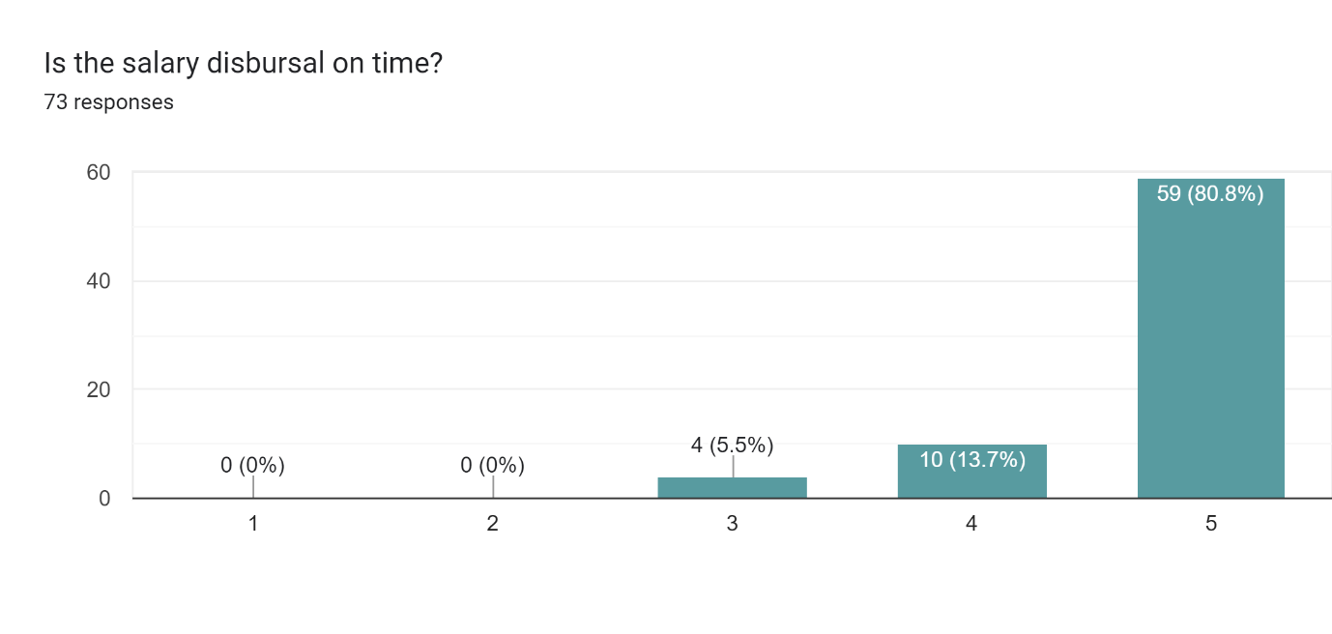

## Promptness in processing of various allowance application

